About the Pedal
The pedal we are building is a transistor fuzz-box (guitar distortion pedal) along the “Fuzz Face” lines. The Dallas-Arbiter Fuzz Face was one of the earliest distortion units. It appeared in the 1960's and was made famous by (among others) Jimi Henrix.

Our design is based on more recent Fuzz Face offspring - the Zvex “Fuzz Factory”. This pedal contains an additional transistor to boost the input and give a much richer distortion than the Fuzz Face that is less fussy about the characteristics of the individual transistors. It also allows for much more tweaking of the sound via additional control potentiometers... while the Fuzz Face has Fuzz and Volume controls, the Fuzz Factory has 5 knobs! (Volume, Gate, Compression, Drive, Stability).

Our version only has 2 knobs (Drive and Volume) on the outside of the box, but we do allow pre-setting of the Compression and Gate knob settings via “trimmers” (miniature potentiometers) on the circuit board, so you still have a lot of possible variation in sound. (If you want to take it further, you can use the same circuit as the core of a 5-potentiometer Fuzz Factory clone just by adding the extra control potentiometers)

Just like original guitar amplification used thermionic valves (“tubes”) because suitable transistors did not exist at the time, the original Fuzz-Face pedal was based on the Germanium Transistor technology of the time (before the more robust Silicon became commonplace).

However, in the same way that many guitarists prefer the warmer overdriven sound of tube amps to the harsher clipping of (technically superior) transistor amplification, many fuzz-type pedals continue to use old Germanium transistors due to their characteristic distortion, which is richer and less “clippy” than Silicon. Just like the Fuzz Factory pedal we're using AC128 (or the equivalent Russian GT1322) Germanium transistors for this project.

Checking the goodies!
You should have a project box...

… and the following hardware items:

Foot Switch, Mono jack socket, Stereo Jack socket, B10K Potentiometer, B4.7K Potentiometer, 2 knobs, LED holder in 3 parts, battery clip, 4 rubber feet.

Check the items and let us know if anything is missing. And dont worry, the electronic components will be along shortly...
Drilling The Box

Listen up before you start drilling! The box is designed to work as a pedal with the “lid” actually forming the base at the bottom. This means you will be drilling the holes in the “bottom” of the box – no holes will be drilled in the lid!

Got it? Good :) If you're not sure, please ask before you drill, since we cant fill the holes in afterwards! (Maybe take the lid off now and put it somewhere safe that's nowhere near a drill)

Here is a suggested drill layout in order to fit the 3PDT footswitch, 5mm LED holder, 2 potentiometer and 2 jack connectors for the BuildBrighton stompbox workshop.

Some of the holes may need to be enlarged using a reaming tool (this is easy since the Aluminium is soft). It is much better to drill a hole that is too small, and widen it, than to drill a hole that is too big!

Introducing the Circuit
We'll be assembling the circuit below on “stripboard” (also called “Veroboard”). This is a common type of electronic prototyping board which is drilled with a matrix of holes (usually on a 0.1” / 2.54mm grid) and has horizontal strips of copper bonded to the back.

We can solder components through the holes on to the copper, and we can break the copper (using a special track cutting tool) where necessary. In order to build up almost any circuit.

Stripboard is a great base for prototyping simple circuits and is the best way to build electronic devices without needing to obtain or manufacture PCBs (Printed circuit boards)

Here is the stripboard layout we'll be building.

Identiying the resistors
This circuit uses the following resistors which can be identified using their colour codes (or a digital ohm meter!)

Preparing The Stripboard
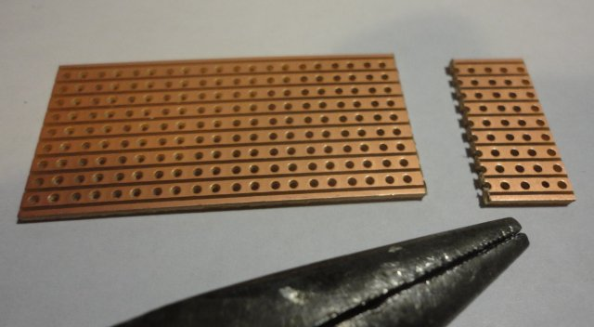
The first step is to break the board to get it to the size we need. We'll need 20 clear columns for our circuit so, using a ruler and a knife, make a deep score on both sides of the board at the 21st column . Now use long nosed pliers placed parallel to the score to cleanly break the board as shown.

Discard the small piece and and use fine sandpaper to clean up the edge of the larger piece.

Adding the jumper wires
We'll add the wire “jumpers” next – these are pieces of wire soldered to join various tracks together. These will give us handy placemarkers when we turn the board over to break the tracks.

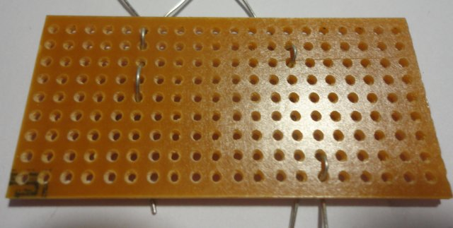
Cut the wire to approximate length (an inch or so) before inserting it in the board. Bend it to a “U” shape and pass it through the holes. Insert all the wires and carefully check they are in the right places before soldering anything (Its always worth triple checking before soldering to save the pain of desoldering components later!). Solder and trim the wires close to the board.
Adding the track breaks
It is always good practice to add the track breaks before soldering components. Otherwise existing solder joints can get damaged when making a break next to them.
Use a special track cutting tool to make the holes. Press gently and twist the tool, applying more pressure until it “bites”. Its suprisingly quick to make a good break – don't overdo it or you might go right through the board!
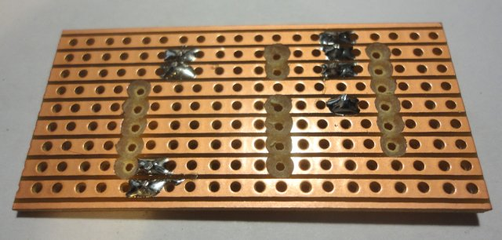
Check that no copper is left bridging the rim of of the break, and that no “bridges” of copper swarf are left between tracks. You could give it a light rub with fine sandpaper to be sure its all clean.
One of the most tricky problems to track down later is when a break is not complete and a tiny bridge of copper is left, Its worth double checking now when this is easy to fix.

Adding components
Its good practice to add components from the shortest to the tallest, since it makes it easier to hold components steady when soldering them with the board inverted.

Lets start with the sockets for the transistors. Solder the middle leg first, then make sure the socket is flush on the board before soldering the outer legs.
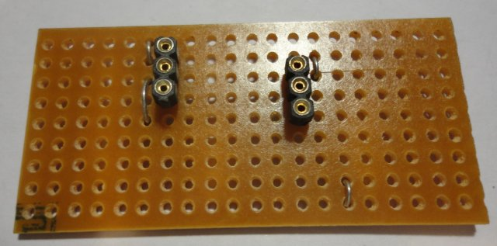
Now lets add the resistors that are to be mounted fully horizontally against the board
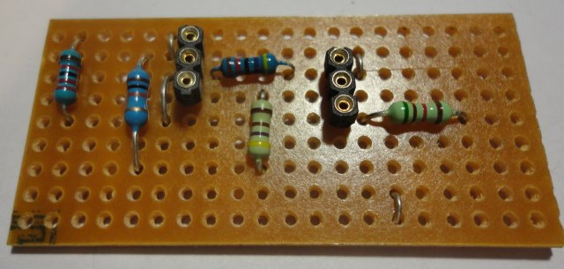
Now the Silicon transistor, polyester box capacitor and the two trim potentiometers. For the transistor and the trim pots make sure you have them oriented the correct way round.
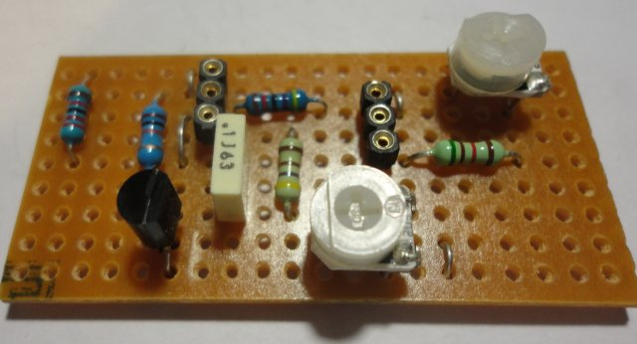

Now add the remaining resistors. Mount these “standing up” as needed (you might only need to do this on the 220K resistor beside the transistor)
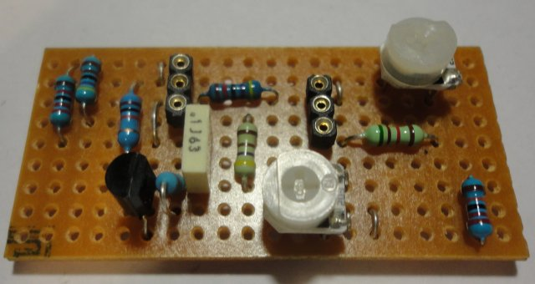
And now add the two electrolytic capacitors. Be careful to get them the right way round (the negative terminal – or cathode – is marked on the case, usually with a stripe)
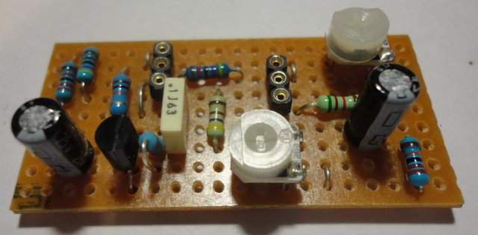
And that does it for now!

Before adding wiring, examine the back of the board and check all connections are good and that there is no solder debris “bridging” the gaps between the tracks. It is useful to run an soldering iron quickly down the length of each gap to make sure any tiny solder blobs are picked up.
Trim down any potruding component legs.

Wiring the Pedal
The following disagram shows the connections between the pedal hardware and the circuit board.

The diagram is presented as you look inside the pedal from the back, so it is mirrored from the normal view, the 4.7K VOL potentiometer is shown on the left and the 10K DRIVE pot on the right.
It can be difficult to orient the footswitch since it is almost square. It is actually rectangular and the longer edges should be parallel with the longer sides of the pedal case, but if you have any doubts please ask before soldering any wires to it.

Try to keep wires as short as possible or you'll find they take up a lot of space and you might not fit everything in the box. It is good practice to twist or plait parallel sets of wires together (e.g. VOL_A/VOL_W/GND as a plait, LED_DIM/LED_BRI as a twisted pair, the LED wires as a twisted pair, DRIVE/9V as a twisted pair).

Dont forget the 10uF capacitor soldered to the DRIVE pot (check the polarity)

Here are the hook up points on the strip board.

Here is what my wiring looked like. I tried to keep all the wires as short as possible and use colour to distinguish the wires.

Here are the wired connections with the board

Inserting the Germanium Transistors
The two transistors are identical types, but Germanium transistors can vary wildly in their characteristics such as current gain (hFe) and we'll help you select a good pairing for use in the circuit.

Transistors must be inserted in the circuit the correct way around, but these older types do not have the helpful D-shaped case of newer types, so it can be tricky to identify the orientation.

However the legs are arranged in a “triangle” as shown above, so this should allow you to orient them correctly. Cut the legs short and insert them in the sockets as shown below. You will likely need to bend the legs through 90 degrees as shown to fit the circuit inside the pedal case. Make sure the legs are not touching each other.

To fit the board inside the case, foam tape works well. Cut a strip which potrudes about 3mm each end when the tape is stuck to the reverse of the stripboard.

Stick the board to the base, but select a position where the tall capacitors will not jam against the potentiometers preventing the case being closed.

The board should now fit snugly into the base, with the edges of the tape wrapping around the ends to prevent the wiring touching the metal case. When closing the case, stash the excess wire above the board so that when closed it presses on the board preventing it coming loose.

You're pretty much done! Before you screw the case closed, be sure to plug in a guitar and play with the settings on the two trim pots.

